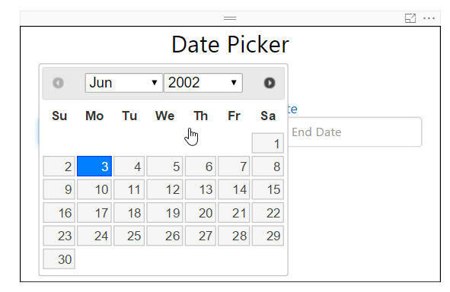 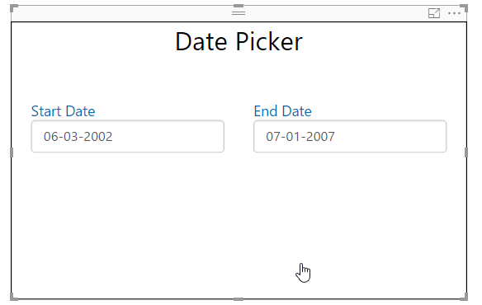

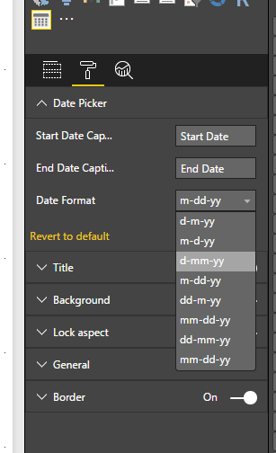

Date Picker:

1. Start Date Caption: Specify the caption for first date picker
2. End Date Caption: Specify the caption for second date picker
3. Date Format: It is a drop-down option to specify the format of date to be displayed
4. Font Size: Change the font size of both date picker title
5. Font color: Change font color of date picker caption.